**Input:**  
f(x): x2-2x-3

x =

x0 = 4

EPS= 0.00001

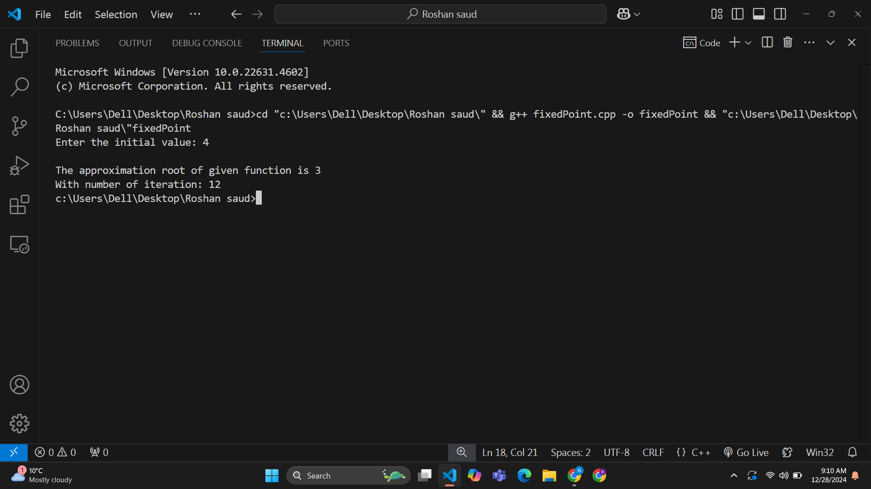**Output:**

**Input:**

F(x): x*ex = 1

x = 1/ex

x0 = 1

EPS = 0.00001

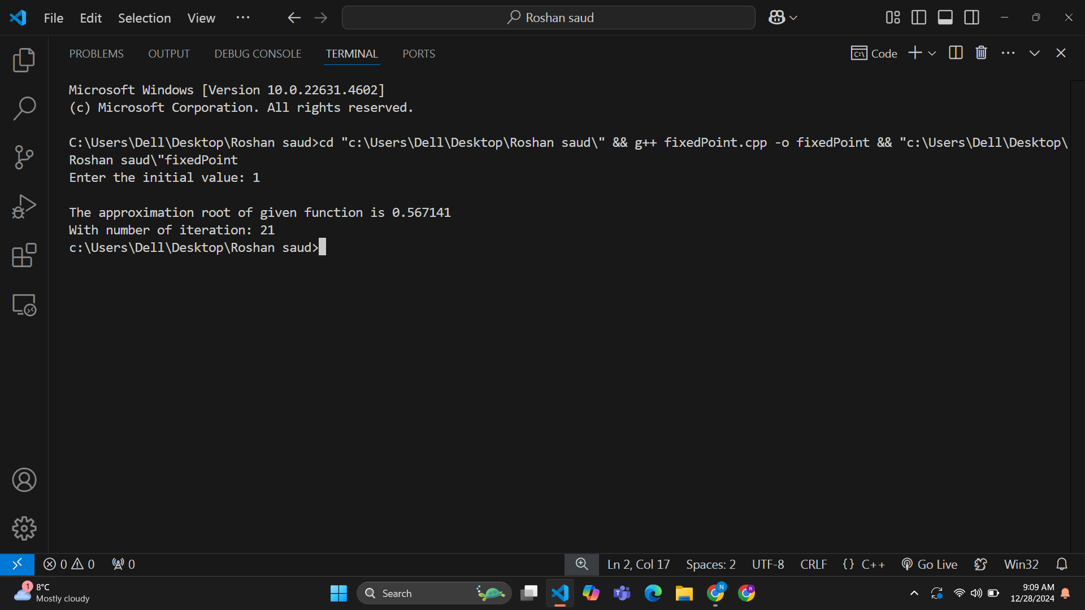**Output:**